# Ads – SPA with AngularJS Lab

The **goal of this lab** is to continue the development of the Online Ads AngularJS application: add paging when displaying the public ads.

## Paging for the Public Ads

1. Research how to retrieve a **specific page** of ads from the Ads REST service:
   * You should perform a **HTTP GET** request from <http://softuni-ads.azurewebsites.net/api/ads>
   * You should pass two parameters: **pageSize** and **startPage**
     + E.g. [http://softuni-ads.azurewebsites.net/api/ads**?pageSize=2&startPage=3**](http://softuni-ads.azurewebsites.net/api/ads?pageSize=2&startPage=3)
   * The service will return the ads as JSON object: **{numItems: *n*, numPages: *p*, ads: [*ad1*, *ad2*, …]}**.
2. Find a UI control for paging in AngularJS – a **pager**.
   * You may use the **UI Bootstrap for AngularJS**: <http://angular-ui.github.io/bootstrap/#/pagination>.
   * You are free to implement the paging from scratch (this will cost you more time and effort).
   * You may use any other pagination library / UI control (at your own risk).
3. Include the Angular UI Bootstrap Pagination library to your project:
   * The library source code is already added to your project skeleton:
     + The pagination AngularJS module: **lib/ui.bootstrap/ui.bootstrap.pagination-0.12.0.js**
     + The HTML template for rendering the pager: **templates/pagination/pagination.html**
   * Include the pagination module JS file in your **index.html**.
   * Include the **ui.bootstrap.pagination** module in your Angular app. Modify the **app.js** file:

|  |
| --- |
| **app.js** |
| …  **var *app*** = **angular**.module(**'app'**, [**'ngRoute'**, **'ngResource'**, **'ui.bootstrap.pagination'**]);  … |

10 score

1. Add a **pagination** UI control in in your home view (**templates/home.html**):

|  |
| --- |
| **home.html** |
| <**pagination total-items="ads.numItems" ng-model="adsParams.startPage"**  **items-per-page="adsParams.pageSize" ng-change="reloadAds()"**  **max-size="9" boundary-links="true"**>  </**pagination**> |

* The paginaton control will take the total number of items from the curent scope (**ads.numItems**).
* The page size comes also from the scope (**adsParams.pageSize**). We will display 2 ads per page to simplify testing.
* The current page is data-bound to the scope variable **adsParams.startPage**.
* Then the user changes the current page (clicks the pager), the scope function **reloadAds()** will be called.

10 score

1. Test your application to ensure the pager is loading correctly.
   * The pager UI control should be shown at your home screen:

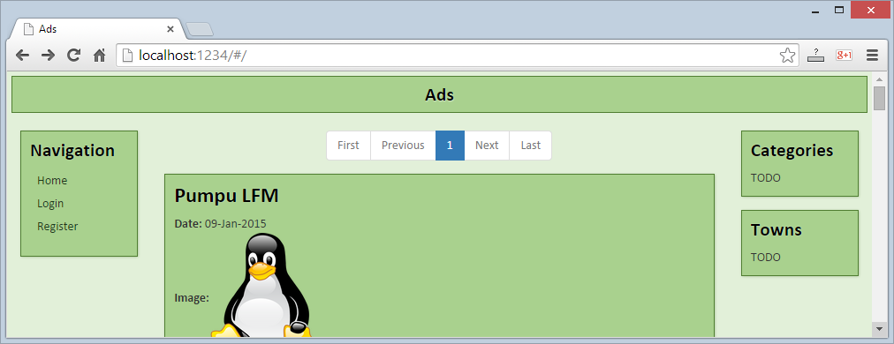

* + Check for errors at the Web browser's development console:

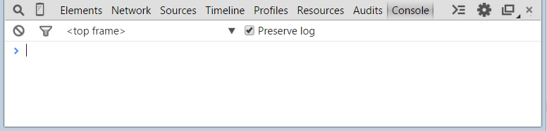

1. Modify your **HomeController** to initially load the first page in the **$scope** and reload the ads when the current page is changed:

|  |
| --- |
| **HomeController.js** |
| **'use strict'**;  ***app***.*controller*(**'HomeController'**,  **function** ($scope, adsService, notifyService, pageSize) {        $scope.**adsParams** = {  **'startPage'** : 1,  **'pageSize'** : pageSize        };        $scope.reloadAds = **function**() {            adsService.getAds(                $scope.**adsParams**,  **function** *success*(data) {  *//* ***TODO:*** *put the ads in the scope*                },  **function** *error*(err) {  *//* ***TODO:*** *display an error message*                }            );        };        $scope.reloadAds();     }  ); |

15 score

1. Start and test your application. Fix any bugs. Check the development console. It should be error free:

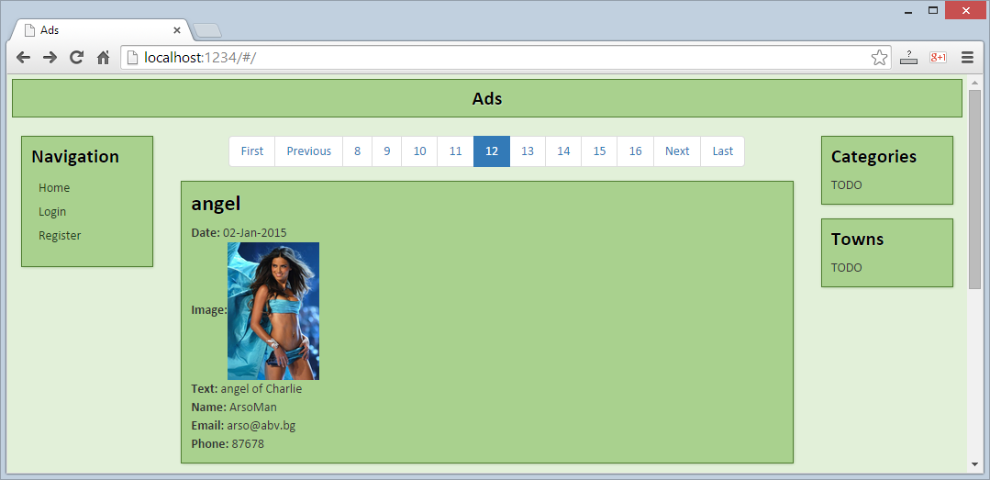



10 score